EXPERIMENT 4

ROLL NO: 240701281 NAME: S Lakshan
Create a prototype with familiar and unfamiliar navigation elements. Evaluate ease of use with different user groups using proto.io

Screen 1:
Sign In page for the destination app
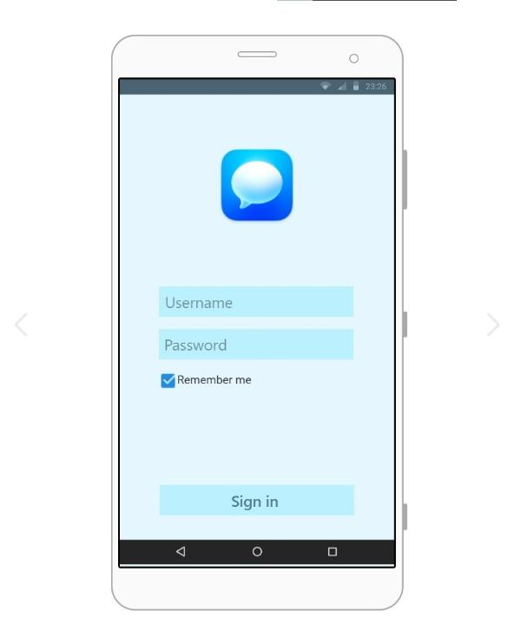
Familiar Icons:
- Sign In Button:
A clearly labeled action button.
Standard primary action element.
Possibly Unfamiliar or Missing Icons:
- Missing Back Button:
Users may not know how to navigate to the previous page.
- Missing Sign Up Option:
New users may not know how to create an account.
- Missing Forgot Password Link:
Users who forget their password may not find recovery options.
- Missing Page Title (Login):
Lack of a clear heading may confuse users about the current screen.

Screen 2:
Home page:
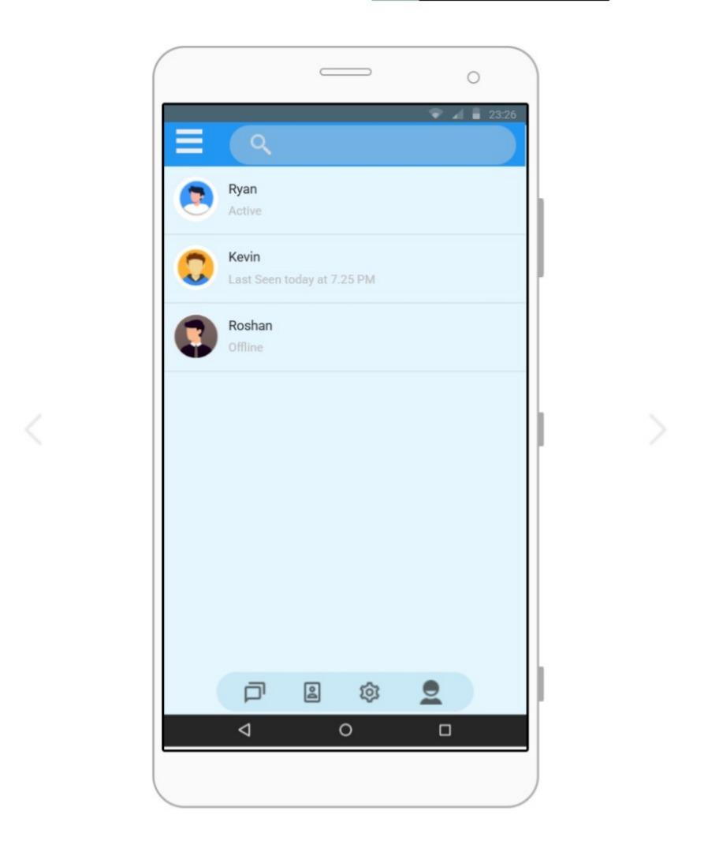

Familiar Icons:
- Hamburger Menu – Top Left:
Common icon used to open a navigation drawer or sidebar.
- Search Icon – Top Bar:
Widely recognized symbol for searching contacts or conversations.
- Profile Avatars – Next to Names:
Circular user images commonly used in chat applications.
- Status Text (Active / Last Seen / Offline):
Standard way to show user availability in messaging apps.
- Bottom Navigation Icons:
Common layout for switching between main sections like chats, contacts, settings, and profile.

Screen3:
Home Page with Navigation Drawer
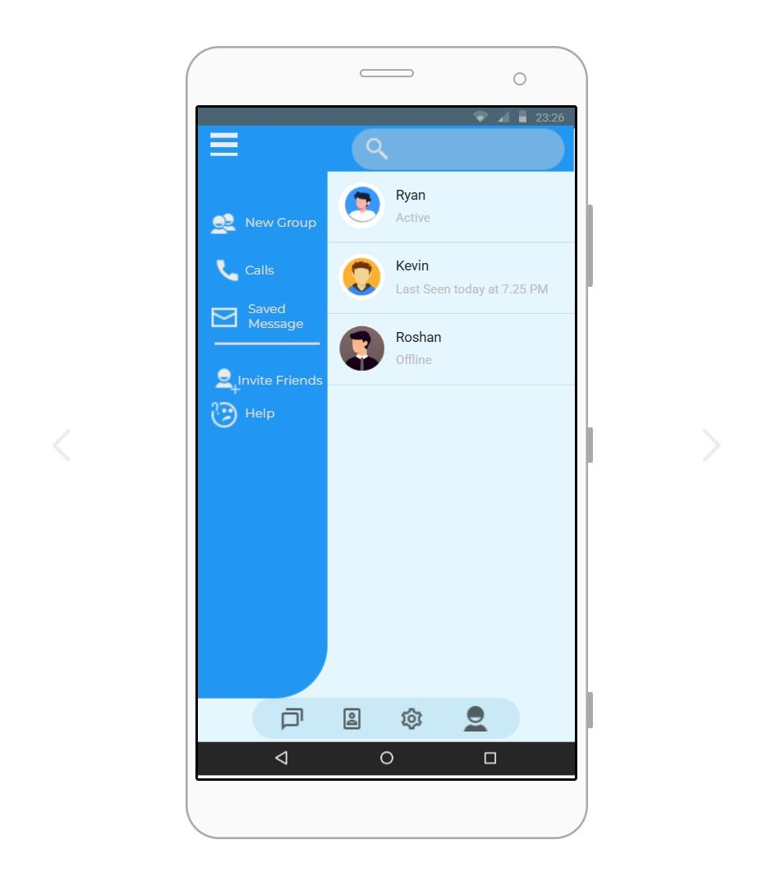
Familiar Icons:
- Hamburger Menu – Top Left:
Standard icon used to open the side navigation drawer.
- Search Icon – Top Bar:
Commonly used to search chats or contacts.
- Navigation Drawer (Sidebar Menu):
Widely used mobile pattern for accessing additional options.
- Call Icon – Next to “Calls”:
Recognizable symbol for call-related features.
- Envelope Icon – Next to “Saved Message”:
Common symbol for messages.
- Help Icon – Next to “Help”:
Standard representation for support or assistance.
Screen4:
Chat Screen – Familiar UI Elements
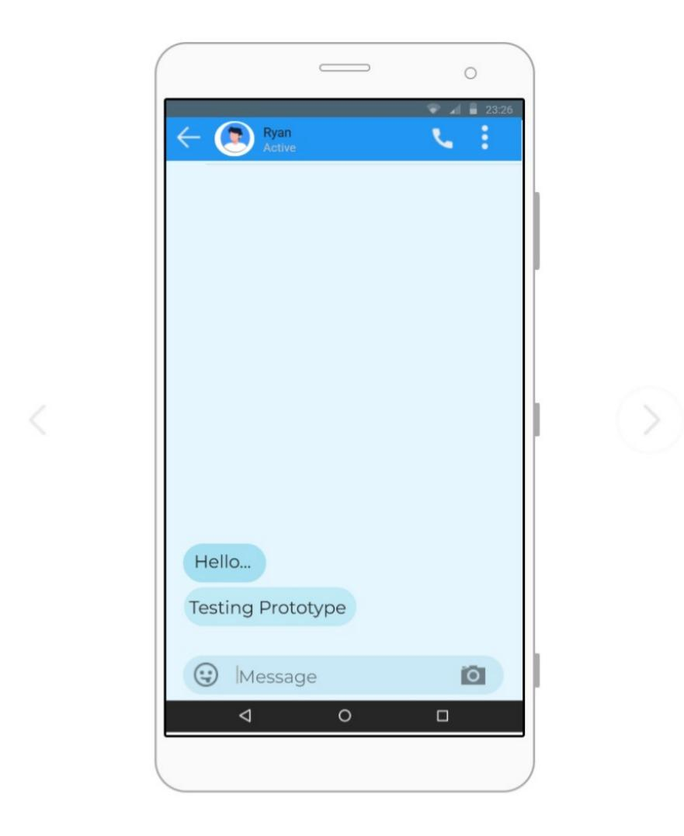

1. Back Arrow (Top Left)
- Commonly used across messaging apps for returning to the previous screen.
- Helps users quickly navigate back without confusion.
2. Call Icon (Top Right)
- Standard icon indicating the ability to make a voice call.
- Instantly recognizable due to its frequent use in communication apps.
3. Three-Dot Menu
- A familiar symbol for additional actions or settings.
- Users expect this to open a small menu for chat-specific options.
4. Message Input Field (Bottom)
- Standard text area used for typing and sending messages.
- Consistently placed at the bottom in almost all chat applications.
5. Emoji and Camera Icons
- Commonly found within chat input bars for quick emoji access and media sharing.
- Their placement makes interaction intuitive and predictable.
Screen 5:
Profile Screen – Familiar UI Elements
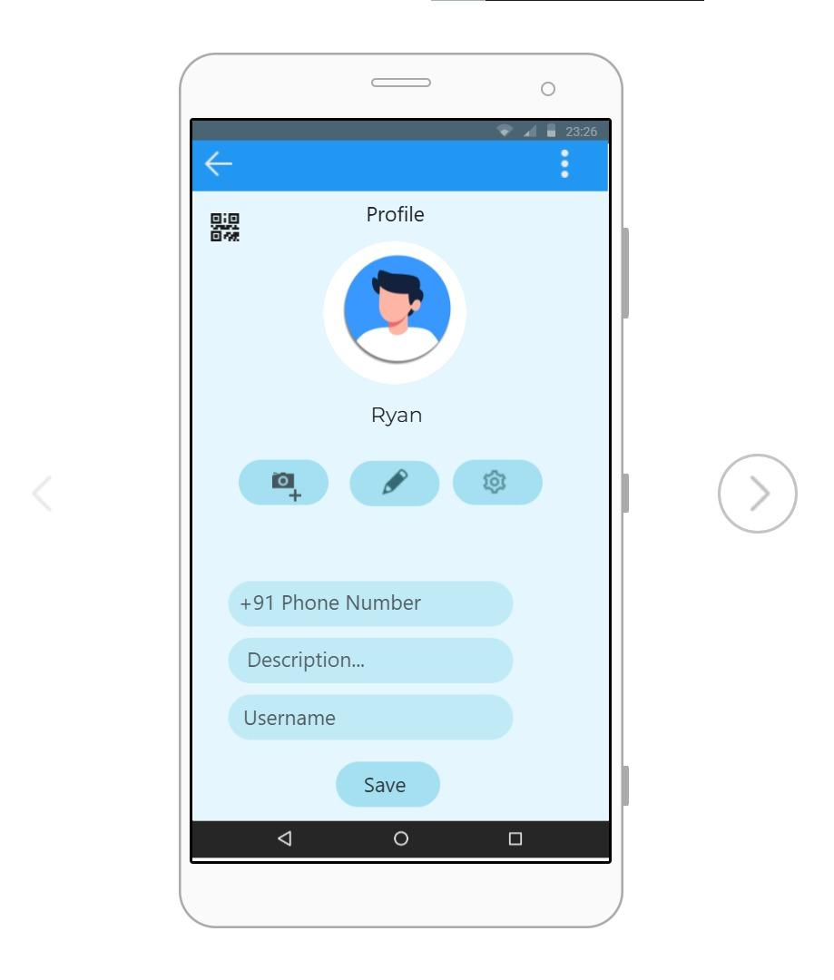

1. Back Arrow (Top Left)
- A widely recognized navigation tool to return to the previous page.
- Maintains consistency across app screens.
2. Profile Picture (Center)
- Circular avatar is a standard representation of user identity.
- Positioned centrally to highlight user information.
3. Camera Icon for Photo Update
- A known symbol for changing or uploading profile photos.
- Users easily understand its purpose without explanation.
4. Edit (Pencil) Icon
- Universally used to indicate editing of information.
- Makes profile customization simple and clear.
5. Settings (Gear) Icon
- Common icon for managing account or profile settings.
- Helps users locate configuration options quickly.

Prototype Link: https://pr.to/O32UMO/

